Computational Biology 2

VM Setup
Peter Sarkozy - psarkozy@mit.bme.hu

Virtual Image
Use the VMWare Image supplied at http://imolarpg.dyndns.org/stuff/ait_vm2.zip.
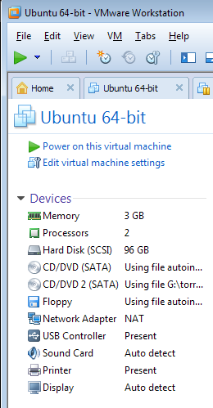
VMWare Player can be obtained free of charge from http://www.vmware.com/products/player/playerpro-evaluation.html
Username: ait
Password: ait
The virtual machine has a 64-bit operating system, and requires a 64-bit host. It is highly recommended to assign the maximum amout of available RAM and CPU cores to the virtual machine, for best performance. This can be done before launching the image.

Importing a virtual machine into VirtualBox
VirtualBox is a cross-platform, open source program that allows running multiple guest operating systems inside any host operating system. We will be performing the lab exercises and the assigned homework should also be prepared inside the virtual machine.
It is required to use a 64-bit host operating system, as the guest machine is 64-bit as well. It is recommended to assign as many CPU cores to the guest system as there are available in the host, and as much RAM as possible.
- Download VirtualBox from the developers’ website: https://www.virtualbox.org/wiki/Downloads
- Install the software, following the install prompts.
- Go to the Machine menu, and select New. Select Expert Mode, and import the virtual machine as below:
  - Make sure to assign at least 2GB of RAM to the machine if you have 4GB in your system, and more if your system has more memory.
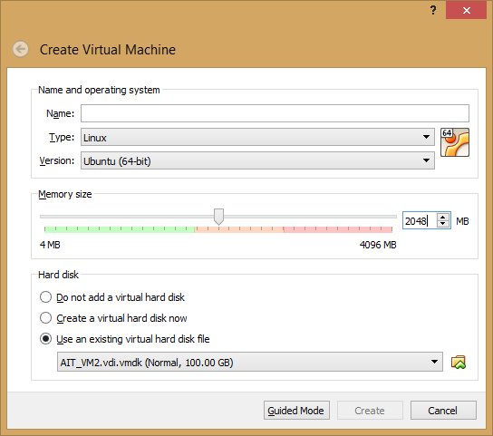
  - Use the AIT_VM2.vdi.vmdk file you have downloaded and unpacked when selecting the hard disk.
- Start the virtual machine, and notify me if the VM crashes on your setup.

